|  |
| --- |
| Software design |
| COURSE MANAGEMENT SYSTEM |
| Version 2.0 |
| Prepared by class SE1623, Group 5  HE150652 - Tống Sỹ Nhật  HE151130 - Đỗ Nhật Minh  HE151190 - Nguyễn Quang Việt  HE153023 - Trần Văn Thuận  HE153409 - Nguyễn Công Khanh  October 17, 2023 |

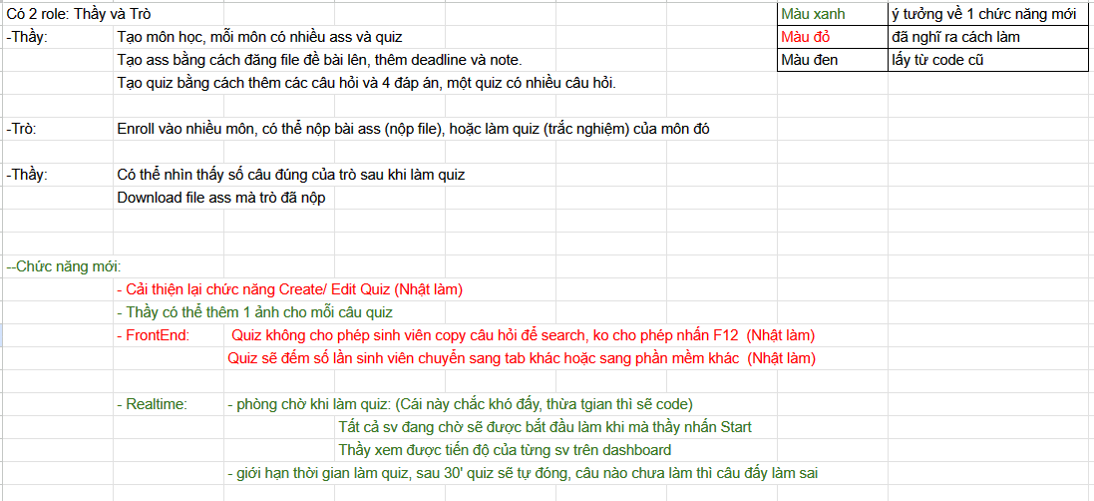

Table of Contents

1. Document description 3

2. SRS overview 3

2.1. List of system users 3

2.2. List of use case 3

2.3. Use case diagram 3

2.3.1. Preliminary use case diagram 3

2.3.2. Use case detail diagrams 3

2.4. Activity diagram of use case scenarios 3

2.4.1. Activity diagram for use case “” 3

3. Data model 3

3.1. Entity Relationship Diagram 3

3.2. Table details 3

3.2.1. Table name: Courses 3

4. Class diagram 3

4.1. List of classes in the Layers 3

4.2. Modeling the Class Behaviors – sequence diagrams 3

4.2.1. Sequence diagram for use case “Do Quiz” 3

5. User Interface Model Design 3

5.1. User interface model design 3

5.1.1. UI when teacher add new quiz 3

5.1.2. UI when student do a quiz test 3

5.1.3. UI when student see assignment 3

5.2. Interface Flow Diagram 3

# 1. Document description

# 2. SRS overview

## 2.1. List of system users

1. Admin: Have all permission for CRUD user (teacher and student)

2. Teacher: Have permission for CRUD course, CRUD assignment, CRUD quiz, RD student in that course

3. Student: Have permission for enroll a course, submit assignments and do quizes

## 2.2. List of use case

Register

Login

CRUD User

CRUD Course

CRUD Assignment

CRUD Quiz

RD Student in a Course

Enroll course

Submit assignment

Do quiz

## 2.3. Use case diagram

### 2.3.1. Preliminary use case diagram

[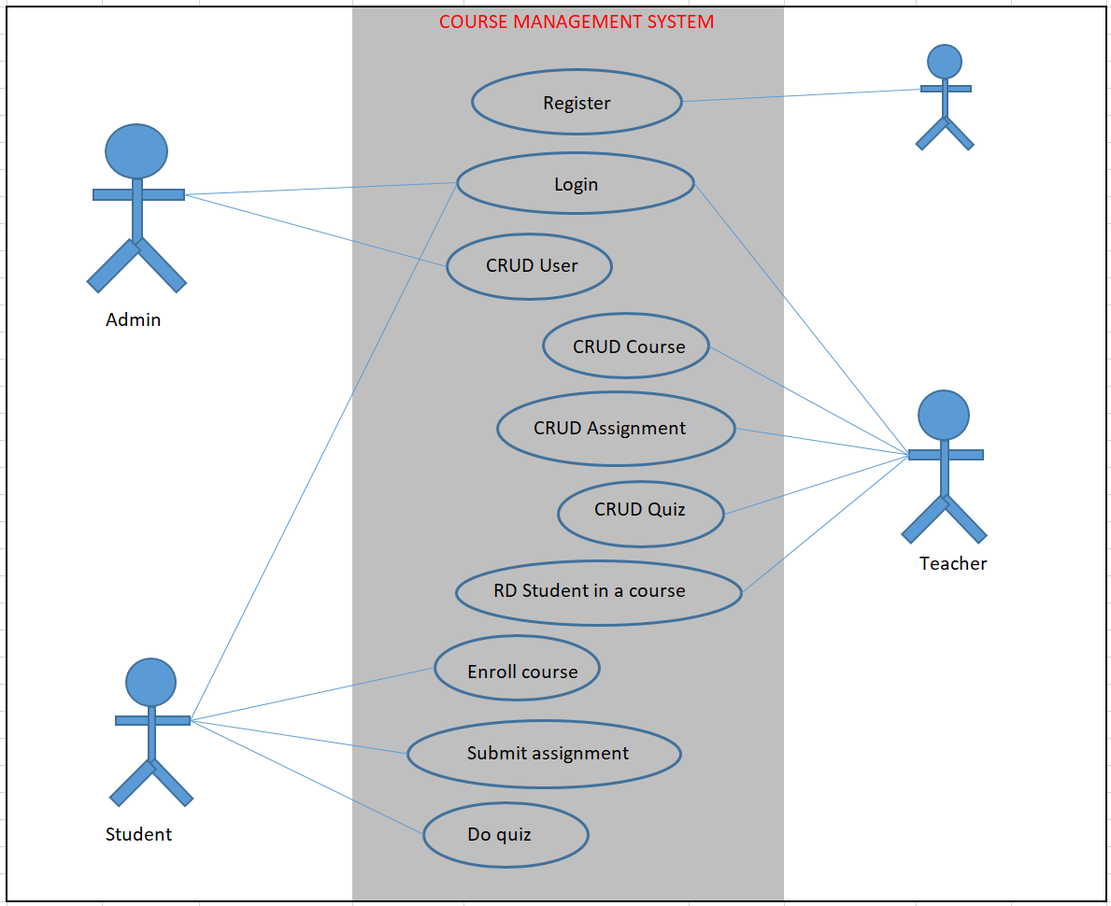](Use%20case%20diagram.xlsx)

### 2.3.2. Use case detail diagrams

#### 2.3.2.1 Use case detail diagram for ”Do quiz”

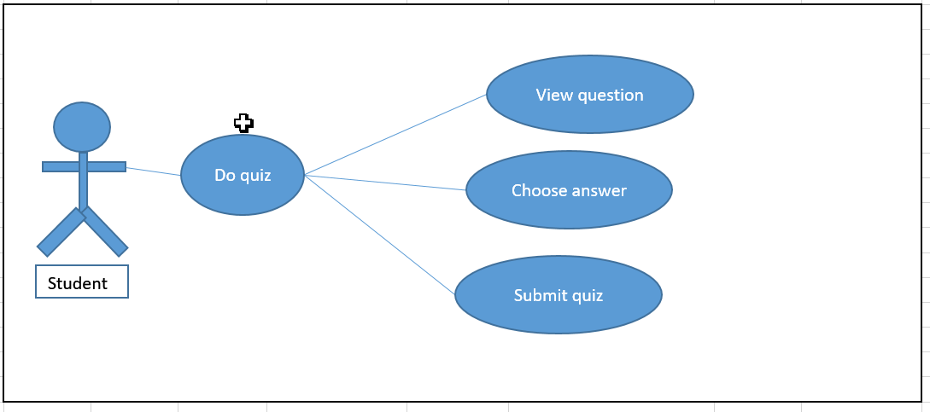

## 2.4. Activity diagram of use case scenarios

### 2.4.1. Activity diagram for use case “Do quiz”

[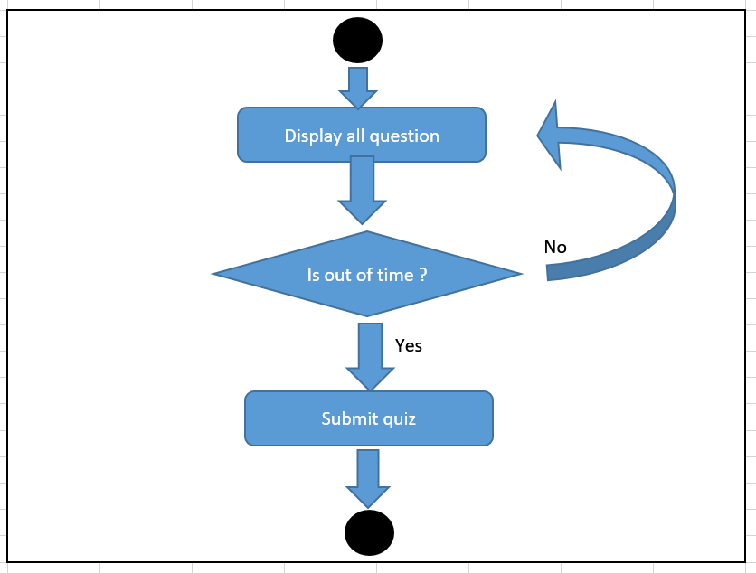](Use%20case%20diagram.xlsx)

# 3. Data model

## 3.1. Entity Relationship Diagram

# 4. Class diagram

## 4.1. List of classes in the Layers

## 4.2. Modeling the Class Behaviors – sequence diagrams

### 4.2.1. Sequence diagram for use case “Do Quiz”

# 5. User Interface Model Design

## 5.1. User interface model design

### 5.1.1. UI when teacher add new quiz

### 5.1.2. UI when student do a quiz test

### 5.1.3. UI when student see assignment

## 5.2. Interface Flow Diagram